Ideation Phase
Empathize & Discover

Date: | 7 Feb 2026
Team ID: | LTVIP2026TMIDS73160
Project Name: | Househunt: finding your perfect rental home
Maximum Marks: | 4 Marks

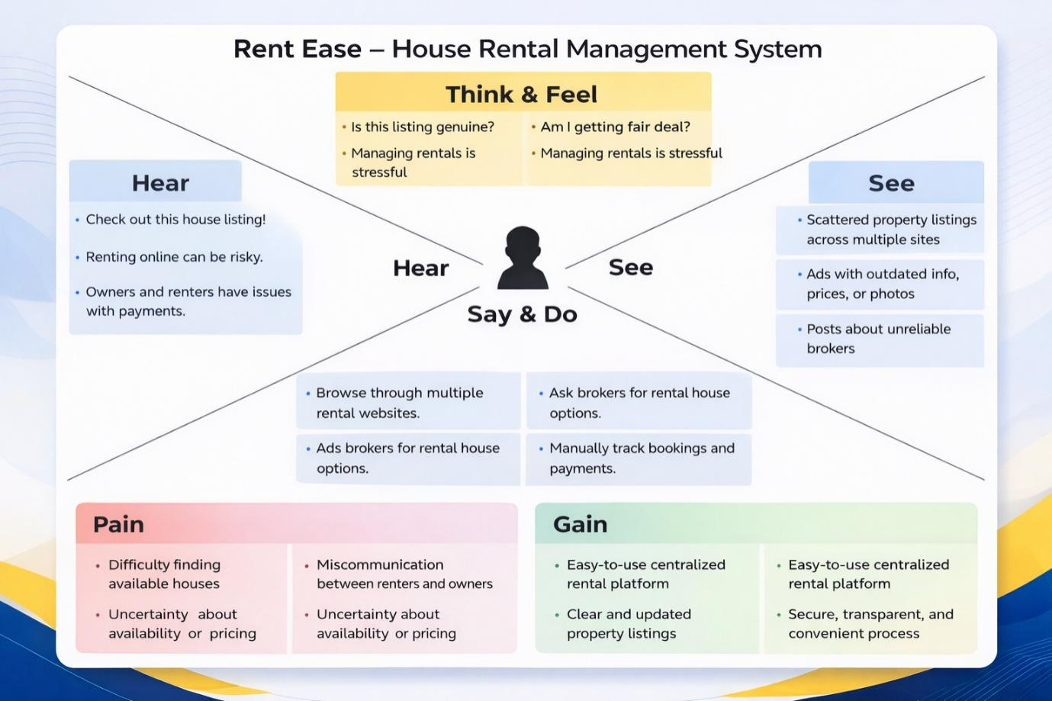

🎯 Target User Persona
Primary User: Renter / House Owner
Context: Searching for houses or managing rental properties

🧍 I AM
A house renter or property owner living in an urban or semi-urban area.
🎯 I’M TRYING TO
- Find a suitable rental house easily
- Manage rental properties efficiently
- Communicate clearly with tenants or owners
- Keep track of bookings and availability

❌ BUT
- The rental process is mostly manual and unorganized
- Property details are scattered across multiple platforms
- There is no proper system to track availability or booking status

🔍 BECAUSE
- Many rental systems rely on phone calls or brokers
- Information is outdated or incomplete
- There is no centralized and secure rental management platform

😟 WHICH MAKES ME FEEL
- Confused while searching for houses
- Frustrated due to lack of transparency
- Worried about trust and security
- Uncertain about availability and pricing

🗣️ SAYS
- “I can’t find reliable house listings.”
- “I don’t know if this house is still available.”
- “Managing tenants manually is stressful.”

💭 THINKS
- “Is this property genuine?”
- “Am I getting a fair deal?”
- “There should be a better digital system for rentals.”

🧍 DOES
- Searches rental houses online
- Contacts owners or brokers
- Visits properties physically
- Manages records manually

😣 PAINS
- Time-consuming house search
- Miscommunication between owners and renters
- Lack of booking confirmation
- Dependence on intermediaries

🎁 GAINS (WHAT USER NEEDS)
- A centralized house rental platform
- Clear property listings with details
- Secure login and booking system
- Transparency and ease of use

